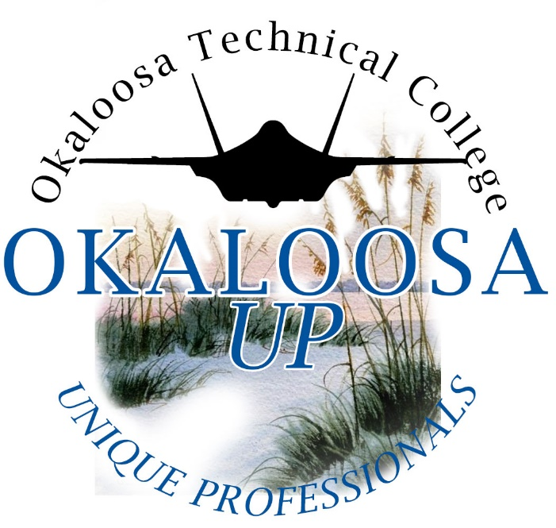

FALL 2022

Completed Application Deadline: May 26, 2022

Okaloosa UP at Okaloosa Technical College
A Florida Postsecondary Comprehensive Transition Program
1976 Lewis Turner Boulevard, Fort Walton Beach, Florida 32547
850-833-3500

Application for Admission
Okaloosa UP is a collaborative partnership between Okaloosa Technical College, the Okaloosa County School District, and community partners. This program aims to provide inclusive post-secondary technical education in state approved career certificate programs for persons with intellectual disabilities. The program will provide direct support in order for students to establish gainful and sustainable employment. Such skills include social skills, technical skills, interpersonal communication, and problem-solving skills. In addition, students will receive assistance for skills specifically related to their program of study (Professional Culinary Arts and Hospitality or Building Trades and Construction Design Technology).
To ensure that Okaloosa UP is the best match for our applicants, we require that an application packet be completed for each student. Upon entering it is expected that students will demonstrate the following minimal requirements:
- Basic functional understanding of literacy (writing/composition) and reading skills
- Basic mathematics understanding and ability to use a smart phone
- Ability to function independently for a sustained period of time
- Can take direction and is respectful and responsive to authority
- Can handle and adapt to change; is not overly stressed when things change
- Potential to be successful in competitive employment situations
- Desire and motivation to complete a postsecondary program
- Be 18-29 years old at the start of the program
- Has earned a high school diploma or the equivalent (ex. GED)
In addition, letters of recommendation are very important, as these describe current levels of performance across many areas.
Applicants will have typically received extensive special education services in the secondary schools, graduating with an ACCESS diploma or equivalent, and would have considerable difficulty succeeding in a traditional college degree program.
This is a certificate program, with program completers receiving a Certificate of Completion of a state approved post-secondary career certificate program and/or an industry recognized credential (ex: SafeStaff, ServSafe, NCCER, OSHA).
Note: Because of space limitations, not all applicants who complete the application and meet the criteria for admission will be granted an interview and/or be accepted into the Okaloosa UP program. All materials submitted to Okaloosa UP will become the property of Okaloosa UP and will not be returned or duplicated for other purposes.
Please call Okaloosa Technical Center, Okaloosa UP program, at 850-833-3500 if you have any questions.

Application Selection Process
An Application Screening Committee will review applications and select students for admission. You will be notified regarding the receipt and completion of application documents and will then be notified if you are granted an interview.
The decision to offer or deny admission to the program will be made by the Screening Committee in their best judgement and in the best interest of the applicant.
Admission will be based on the following criteria:
- Must be 18-29 years old upon acceptance.
- Must have earned a high school diploma or the equivalent.
- Must have a significant cognitive and/or developmental disability that interferes with his/her academic performance according to the American Association on Intellectual and Developmental Disabilities (AAIDD).
- Demonstrate the desire to attend Okaloosa UP and adhere to the Okaloosa UP policies regarding attendance and participation in the Okaloosa UP and Okaloosa Technical College classes (willingness to follow program and college’s code of conduct).
- Clear discipline/incident record (as applicable from high school or previous employment)
- Strong attendance record (as applicable from previous high school or previous employment)
- Demonstrate basic functional understanding of literacy and reading skills
- Demonstrate basic understanding of mathematics
- Demonstrate the ability to function independently for a sustained period of time
- Display a level of social maturity conducive to an adult environment (i.e. educational setting and employment)
- Have the ability to independently maintain self-care and personal hygiene
- Have reliable transportation or public transport
- Have a support system committed to a collaborative partnership, such as the parent/guardian/family support of the student’s participation in the program
- The applicant must have the potential to successfully achieve his/her goals within the context of the Okaloosa UP program’s content and setting.
Please complete all sections of this application. It is acceptable for the applicant to receive support, if needed, in completing the application. You may attach additional information and pages for writing space if needed. All information is confidential and will not be shared with any outside agencies unless written agreement is provided by those filling out the application. Information will not be returned or duplicated for any purpose.

APPLICATION CHECKLIST

Applicant Name: _____________________________________________________________
Once your completed application has been submitted, you will be notified of receipt of completed application by letter. Note: Applications will not be considered until ALL requested information is received.
The application can be typed and/or printed neatly. Include all information below. Letters of Recommendation must be returned by the individual completing the recommendation to the following address:
Okaloosa UP Program
Okaloosa Technical College
Attention: Jo Grice, OUP Program Director
1976 Lewis Turner Boulevard
Fort Walton Beach, Florida 32547

Application Checklist:

- Release and Exchange of Information
- Student and Family Information/Emergency Contact Information
- Employment History
- Educational History
- Personal Support Inventory- completed by Family/Guardian
(addendum to application, may be completed during interview)
- Student Questionnaire- student completed (indicate if scribe is used)
- Letters of Recommendation- Letters of Recommendation should be submitted by three persons who have known the applicant for one year or longer. Two references must be professional, one should be personal. Each recommendation should address each of the following areas:
- Education
- Vocational/Employment
- Community Involvement
Letters must be submitted using the Recommendation Forms included in this packet and should be returned to Okaloosa UP at Okaloosa Technical College by the individual writing the recommendation.
- High School Academic Transcripts
- Most recent Transition Individual Education Plan (TIEP) and any postsecondary program records
(students are only eligible for this program if they have been evaluated and reported with an IQ score or 69 or below)

RELEASE AND EXCHANGE OF INFORMATION

Okaloosa UP at Okaloosa Technical College
(A Florida Postsecondary Comprehensive Transition Program)

Okaloosa Technical College recognizes all written documentation obtained to verify a disability and plan for appropriate services as confidential. However, it may be necessary for our staff to exchange some information about you with the OTC faculty and staff in order to provide educational opportunities and experiences on and off campus. This exchange will occur only with your written permission, as given in this document below, and with the understanding that only information necessary for the purposes of accommodation and academic progress will be communicated.

I (name), _________________________________________________________________, give permission to exchange information about me with the offices/individuals indicated below:

_____ School District(s)
_____ Okaloosa County School District Transition Specialist
_____ School Personnel
_____ Department of Vocational Rehabilitation
_____ Admissions Office
_____ Course Instructors
_____ Financial Aid Office
_____ Registrar’s Office
_____ Tutor/Mentor
_____ Parent/Guardian: _______________________________________________________
_____ Parent/Guardian: _______________________________________________________
_____ Other: _________________________________________________________________
_____ Other: _________________________________________________________________

_____ I agree, as part of the application process, to waive my right to access the student recommendation form.

_____ I agree, as part of the application process, to waive my right to access, duplicate or withdraw sections of the application to use for any other purposes.

Signature of Student: _______________________________________________________________

Signature of Legal Guardian, if applicable: ___________________________________________

Date: ________________________________________________________________________
STUDENT INFORMATION
& BACKGROUND

To be completed by: Student and Parent/Family/Guardian/Support Person

STUDENT INFORMATION

Last Name | First Name | Middle Name
Home Phone | Student Cell Phone | Date of Birth
Address

City | State | Zip Code
Student Email Address:

Parent/Guardian Email Address:
*Disability(ies) |  | *Full Scale IQ Score

*Your IQ/Disability is confidential. Under federal law, this information is protected and will not be disclosed to unauthorized parties. Disclosures may be authorized for the purpose of available financial aid, academic transcripts, or accountability research through the Florida Center for Students with Unique Abilities.

How did you hear about the Okaloosa UP program? (please check the option that applies to you)
_____ Social Media (specify)___________________________________________________________________
_____ ThinkCollege.net
_____ From Okaloosa Technical College student(s)
_____ Conference Attendance
_____ Transition Fair (specify)________________________________________________________________
_____ Other: ________________________________________________________________________________
EMPLOYMENT HISTORY

Work/Internship Experience
Employer/Contact Information | Job Responsibilities | Paid work or internship? | Dates at this Job | Reason for Leaving

Volunteer Work Experience
Employer/Contact Information | Job Responsibilities | Dates at this Job | Reason for Leaving

EDUCATIONAL HISTORY

Name of Institution | City, State | Years Attended | Reason for Leaving

Did/will you receive a high school diploma? | Yes No | Date received:
What type of high school diploma did you receive? | (circle)  Standard High School Diploma/ACCESS- 24 credits  Standard High School Diploma/ACCESS- 18 credits  Standard High School Diploma/ACCESS- Academic and Career Option  Special Diploma
Did/will you receive a high school certificate of completion? | Yes No | Date received:

- What were your favorite subjects in high school?

- What subjects in high school were the most difficult for you?

- How do you learn best (small groups, hands on, etc.)?

- Describe what skills/strengths you have in the following areas:

Independent Living Skills:

Employment/Technical Skills:

Social Skills/Communication:

- Did you participate in general education classes at your high school?
If yes, list inclusive subjects:

Were any accommodations/modifications used in general education? If yes, describe:

Was additional adult support present in the general education classroom? If yes, explain:
STUDENT QUESTIONNAIRE

Why do you want to be an Okaloosa UP student?
_______________________________________________________________________________________________________________________________________________________________________________________________________________________________________________________________
Describe what skills you would like to learn in the following areas:
Independent Living Skills _______________________________________________________________________________________________________________________________________________________________________________________________________________________________________________________________
Employment/Technical Skills
_______________________________________________________________________________________________________________________________________________________________________________________________________________________________________________________________
Social Skills/Communication
_______________________________________________________________________________________________________________________________________________________________________________________________________________________________________________________________
What kinds of jobs are you interested in after you leave high school or college?
__________________________________________________________________________________________________________________________________________________________________________
Discuss two of your goals for the future upon completion of this program.
- __________________________________________________________________________________________________________________________________________________________________________________________________________________________________________
- __________________________________________________________________________________________________________________________________________________________________________________________________________________________________________
Please use this space to provide any additional information about yourself that you wish to share.
___________________________________________________________________________________________________________________________________________________________________________________________________________________________________________________________________________________________________________________________________________________________________________________________________________________________________________________________________________________________________________________________________________________________________________________________________________________________________________________________________________________________________________________________________________________________________________________________________________________________________________________________________________________________________________________________________________________________________________________________________________________________________________________________________________________________________________________________________________________________________________________________________________________________________________________________________________________________________________________________

STUDENT RECOMMENDATION FORM

LETTERS OF RECOMMENDATION

Please submit 3 Letters of Recommendation from persons who have known the applicant for one year or longer. Two letters should be professional (ex. teacher, employer) and one letter should be personal (ex. church worker, family friend). The recommendations should represent each of the following:

- Education
- Vocational/Employment
- Community Involvement

Make three copies of the Student Recommendation Form and give one copy to each of the persons who you have chosen to complete the letters.

Letters must be returned by each person completing a recommendation to the following address:

Okaloosa UP Program
Okaloosa Technical College
1976 Lewis Turner Boulevard
Fort Walton Beach, Florida 32547
Attention: Jo Grice, Program Director

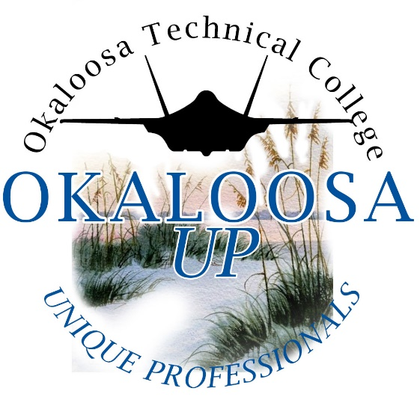

Okaloosa UP
Unique Professionals
at Okaloosa Technical College
(A Florida Postsecondary Comprehensive Transition Program)

STUDENT RECOMMENDATION FORM
To be completed by Personal Reference

Recommendation for (applicant’s name): ______________________________________

The individual named above is applying for admission to the Okaloosa UP program at Okaloosa Technical College. Okaloosa UP offers a career/technical experience that prepares young men and women with intellectual disabilities for competitive employment and independent living through a combination of coursework and career exploration. These students are motivated young adults who have received extensive educational services in either public or private schools and would likely have considerable difficulty succeeding in a traditional technical college certification program. Students should have a strong desire to become an independent adult and must possess emotional stability and the maturity to participate successfully in this program.

With the above information in mind, please answer the following questions to the best of your ability. Attach additional pages as needed.
Please return this form directly to the following address:

Okaloosa UP Program at Okaloosa Technical College
1976 Lewis Turner Boulevard
Fort Walton Beach, Florida 32547
Attention: Jo Grice, OUP Program Director

(Contact information of individual completing the recommendation)
Last Name |  | First Name MI
Title

Organization Name |  | Phone #
Address

City | State |  | Zip Code
Email Address

- How long have you known the applicant and in what capacity?

- Please describe why you feel the applicant would benefit from a postsecondary education experience.

- Please describe the strengths that the applicant may possess that will impact his/her candidacy for this program. (Use the back of this page or attach additional pages as necessary.)

- Please describe any concerns you have that may impact his/her candidacy for this program. (Use the back of this page or attach additional pages as necessary.)

*PLEASE COMPLETE THE PERSONAL SUPPORT INVENTORY AND ATTACH TO THE RECOMMENDATION FORM

